"New Educational Offerings” by SAI 4/18
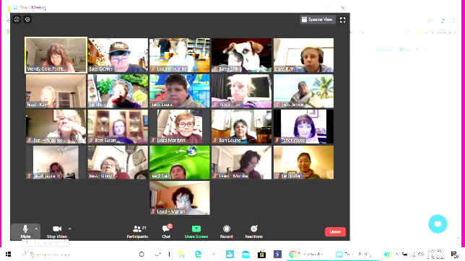
Zoom – Virtual Rehearsal Resources (for participants)
Join Zoom Meeting - For PC & MacUsers
Join Zoom Meeting - For iPhone Users
Join Zoom Meeting - For iPad Users
Join Zoom Meeting - For Android Users

Tips and YouTube Links to Zoom How To’s
To add Zoom to a Smartphone:
1. Access your phone’s App Store (Google Play Store if you have an Android).
2. Search for the Zoom app.
3. Install the Zoom app.
4. When you click on the Zoom icon, you can then choose one of three options:
a. Join a Meeting directly (if you hav

e the Meeting ID and Password).
b. Sign Up if you want to create a Zoom account. Then you can Join a Meeting.
c. Sign In if you already have a Zoom account. Then Join a Meeting.
How to Download Zoom to a Laptop or Computer https://youtu.be/UAa3MADuvsg
How to Rename your Zoom Name (Part Name format for BSC.
Example: Bari Lois Jensen https://youtu.be/1XCMwZqDcNM
How to Mute/Unmute Your Microphone https://youtu.be/-nYIaBQpi60
How to Ask a Question by Raising/Lowering Your Hand https://youtu.be/UzUZeN2DGKE
To be able to see up to 49 Participants on one screen at a time (this probably only works on a laptop or desktop), go to Settings in your profile, then Video. On the right side of this page scroll down until you get to the Meetings section. Then check the box next to "Display up to 49 participants per screen in Gallery View".
Region 1 held a "Zoom 101" training session on May 14, hosted by Beth Paul and presented by Amanda Pitts. Beth and Lala (Laura) are working on making this recorded Zoom session available to Region 1 members. It will probably either be on our Facebook Region 1 Virtual Sharing page, or else on our Region 1 website: www.sai-region1.org/ Beth will let me know when and where it will be available, and I'll let you know.
There are many, many tutorial videos and learning materials on the https://zoom.us/ website in the Resources section.
YouTube has tons of other Zoom tutorial type videos as well. I've been exploring them as I'm trying to learn how to Host/CoHost a meeting.

