Management Team Meeting 3-15-21

In attendance: Wendy Pachter, Donna Doherty, Erin Blanchfield, Joyce Nishinaga, Michele Bokun, Susan Kapur

1. Finance –
   1. The balance is steady in our account. Dues are down because three members have recently left. We are currently at 30 members total.
   2. 5 members are two months late on their dues, 1 member is more than 2 months late.
   3. May 1st is when renewal fees are due and Installation of new officers usually takes place. But each of us have been on for a year so we can go another year if willing. We talked about maybe bringing on someone to shadow a position might be a good idea.
2. Venue Search-
   1. Regent Theater at 7 Medford Street , Arlington is looking promising. Joyce in contact with them to get more information. There is ample parking, they have a 20x30 stage so it would accommodate risers, the contact asked for riser dimensions and Joyce is waiting back on that communication.
   2. Michele mentioned Kid Stock as a possibility at 50 Cross Street in Woburn
   3. We will present the list of requirements for a new venue to our members and see if anyone has other suggestions.
3. Risers - Wendy Leininger has been storing them at her place of work; Post Road Carpet One in Acton. Her boss is asking them to be moved so they have more room for storage. We cannot afford to keep them, store them or move them around. It was decided they must go and we will order new ones when we have space.
   1. Plan A – Donna will call scrap metal places to see if we can turn them in there
   2. Plan B – Post them as free to anyone who will pick them up – Erin provided pictures and Donna will get the dimensions from Wendy L.
   3. Plan C – Paying a company like Got Junk to come take them away

Wendy’s business has been extremely generous to store these for so long at no charge and we want to move quickly to get them out of there for her to not cause any trouble. After we get them out, we should send Wendy and her company a thank you gift basket.

* 1. New Risers – Michele has talked to two different places and we expect about a month delivery. It doesn’t make sense to purchase anything until we find a new venue that can accommodate storage. We estimate a need for 3 accordion sections of risers to be able to accommodate our current membership. We can start with that and always buy more sections as our chorus grows.

1. Membership –
   1. Michele is still trying to dig up some more information on how other choruses has run their virtual guest night. She wants to move ahead and plan a date to get things going – April 27th, 2021
   2. Meetup – Michele will do a demonstration during announcements at rehearsal on 3/16 to show people how to create an account and find BSC on Meetup. It is important that members sign up once and then confirm that they are coming to events to make them look more populated and enticing for others to want to attend.
   3. Michele would like to discuss more next month about getting all members to participate on some team. Meet once a month on zoom and contribute ideas.
      1. Now is a great time to start a show team – come up with a theme and work with Wendy on song selection.
      2. Wendy will reach out to the Boston Saengerfest Men’s chorus and see if they are still interested in doing a show when we can
2. Marketing -
   1. Erin made a suggestion to steal an idea from Grace Notes chorus and maybe provide colored singers masks by part to each member when we return to singing in person. Might be a good bonding thing and make it easy to see where the parts are on the risers!

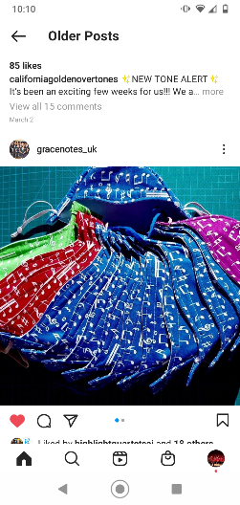

* 1. Laura Murray has been coming up with shirt designs

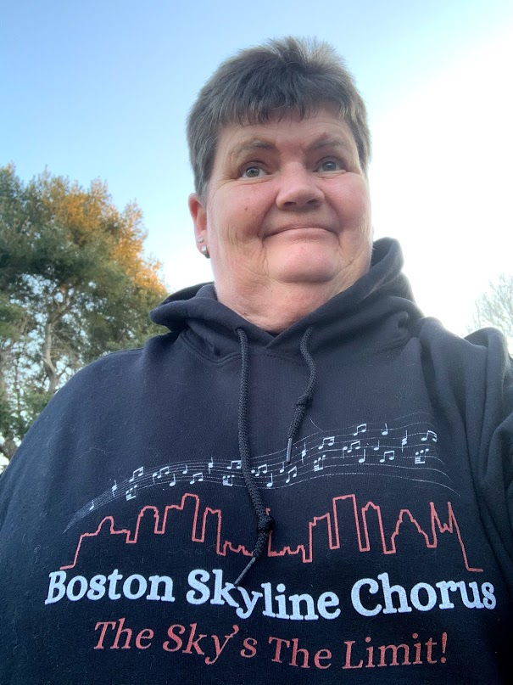

She is very enthusiastic about coming up with new things and is working with Erin on a lot of marketing items, including this. Everyone really loved both designs. Only comments to change was to lose the “.org” on the rainbow hand design and make “Boston Skyline Chorus” bigger. We just need to confirm that the art is Fair Use – did it come from art in her purchased program or is it clipart from the web? Donna’s sister can help with figuring out Fair Use.

* 1. Patti Levernoich from the Region is reaching out to see if members might be interesting in a Regional get together on June 18th. We just need to poll our members to get an idea of how many will be interested. It will be announced at rehearsal and Erin will send out an email to everyone.