



**Deadline for Westborough Feb 17th Event: February 7, 2024**

***FREE for Members*** to attend, ***but pre-registration is still required!***

1. **Pre-registrations are accepted up to the above date. After that, on-site fees will apply.**
2. Members registering on-site will pay a $10 fee.
3. Registration fees for NON-Sweet Adelines or NON-Region 1 attendees are as follows:
   1. Over age 25 - $35 Age 13 to 25 - $25 Age 12 and under - $15

○ Non-members can register with a chorus or through this link: <https://winter-whatchamacallit-non-member-registration-copy.cheddarup.com/>

[***Young***](https://forms.gle/JHw4hj9Kws5UgGhb7)[***Singers***](https://forms.gle/JHw4hj9Kws5UgGhb7)[***in***](https://forms.gle/JHw4hj9Kws5UgGhb7)[***Harmony***](https://forms.gle/JHw4hj9Kws5UgGhb7)[***(February***](https://forms.gle/JHw4hj9Kws5UgGhb7)[***17***](https://forms.gle/JHw4hj9Kws5UgGhb7)[***date***](https://forms.gle/JHw4hj9Kws5UgGhb7)[***only)***](https://forms.gle/JHw4hj9Kws5UgGhb7)[***participants-***](https://forms.gle/JHw4hj9Kws5UgGhb7)[***FREE***](https://forms.gle/JHw4hj9Kws5UgGhb7)

[***Here***](https://forms.gle/JHw4hj9Kws5UgGhb7)[***is***](https://forms.gle/JHw4hj9Kws5UgGhb7)[***link***](https://forms.gle/JHw4hj9Kws5UgGhb7)[***for***](https://forms.gle/JHw4hj9Kws5UgGhb7)[***YSIH***](https://forms.gle/JHw4hj9Kws5UgGhb7)[***registration***](https://forms.gle/JHw4hj9Kws5UgGhb7)

1. Chorus Event Coordinators: Please use the [Region](https://www.sai-region1.org/dbpage.php?pg=view&dbase=uploads&id=87256) [1](https://www.sai-region1.org/dbpage.php?pg=view&dbase=uploads&id=87256) [Event](https://www.sai-region1.org/dbpage.php?pg=view&dbase=uploads&id=87256) [Registration](https://www.sai-region1.org/dbpage.php?pg=view&dbase=uploads&id=87256) [Form](https://www.sai-region1.org/dbpage.php?pg=view&dbase=uploads&id=87256) located on the Region’s website to submit a list of attendees FOR EACH EVENT. This form should be downloaded and typed or printed. Keep a copy for your records and forward the original to

Registrar: Lauren O’Sullivan at lauren.stromer@gmail.com and a chorus check payable to North Atlantic Region 1, mailed to 78 Stowell Rd, Bedford, NH 03110

* 1. **BSC Members wishing to register with the chorus, please let Marian McDermott know no later than 10:00pm Monday, February 5th**; **thereafter up through February 7th, please register directly via the above link & advise Marian of your intent to attend.**

1. Chapter-at-Large members may register with a chorus, OR send an email to lauren.stromer@gmail.com .
2. An accurate attendance count is absolutely necessary in order to plan accordingly for our amazing educational program!
3. All attendees must check in at the registration desk before attending classes.

# **Winter Whatchamacallit Contacts**

* Events Coordinator: Christine Bulgini - cmbulgini@gmail.com
* Education Coordinator: Karen Sweeters - kbsweet@aol.com
* Finance Coordinator and Winter Registrar: Lauren O’Sullivan: lauren.stromer@gmail.com ● Young Women in Harmony: Amanda Pitts - amandaleepitts@gmail.com

***Please NOTE: The following schedules are subject to change. In addition to the classes listed, there will be Personal Vocal Instruction Opportunities.***

**Final schedules and PVI Registration link will be available 2 weeks prior to each event.**

**ES**

Instructors: Julie Jeffery, Cheryl Wilcox, Corinna Garriock, Karen Rourke, Gail

Jencik, Lala Carey, Carol Smolenski, Angie Kunasek, Christine Hayes, Sally Jeffery, Marian Minnich, Carole’ Mensing and Karen Sweeters

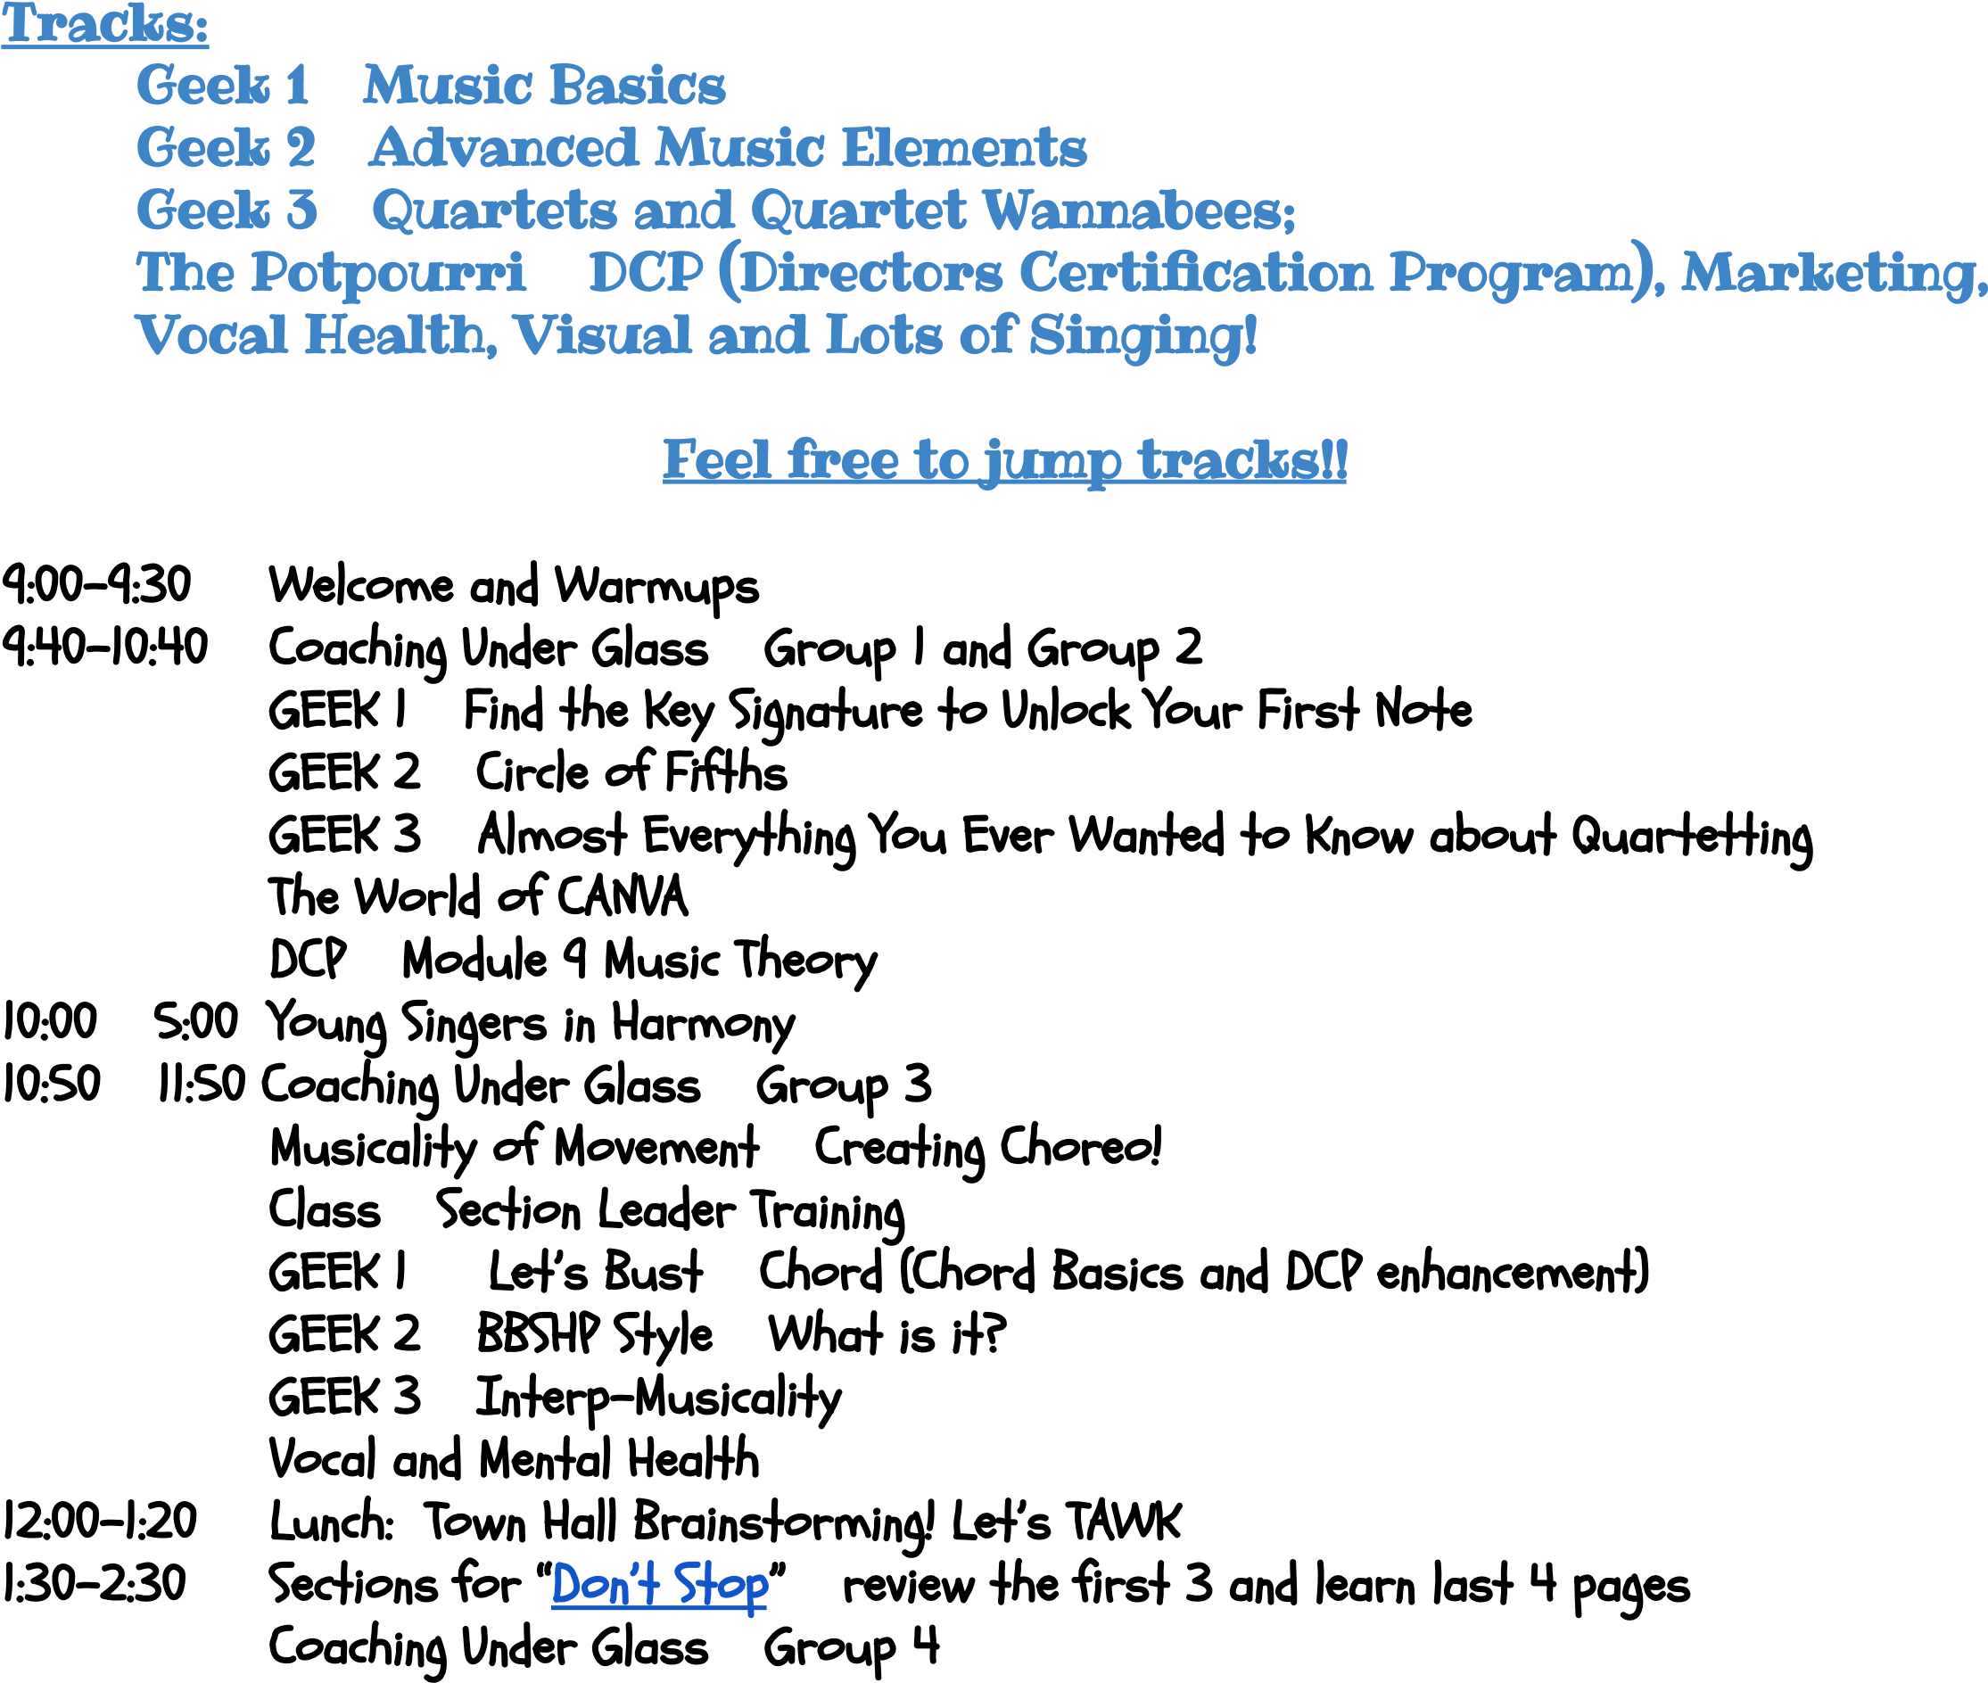

9

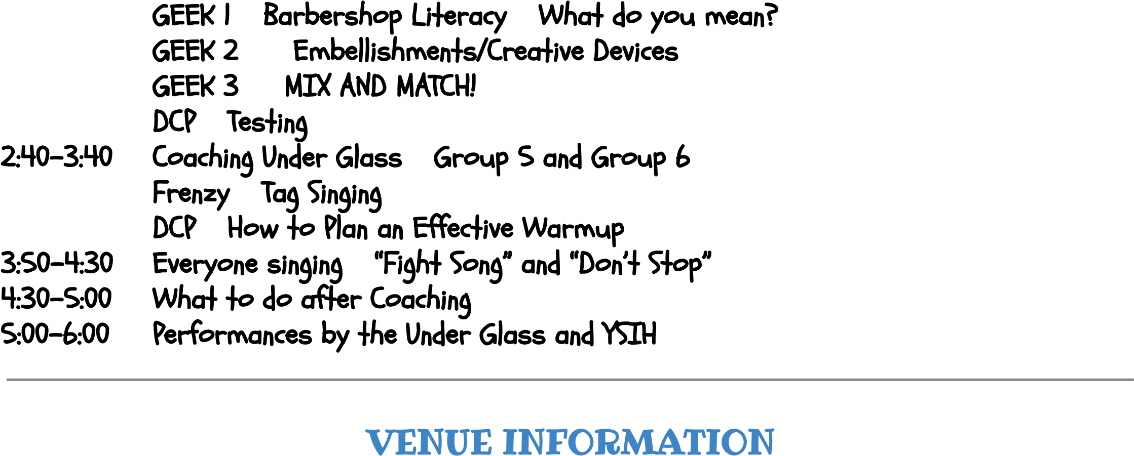

2

|  |  |
| --- | --- |
|  |  |
|  | 183 W Main St,  Westborough, MA 01581 |
|  | Free Parking |
|  | You can bring your own or explore the area for fast food or dining options.  ______________________________________________________________________________________  [Here](https://www.google.com/travel/search?q=hotels%20near%20westborough%20ma&g2lb=2502548%2C2503771%2C2503781%2C4258168%2C4284970%2C4291517%2C4597339%2C4757164%2C4814050%2C4874190%2C4893075%2C4924070%2C4926818%2C4965990%2C4990494%2C72277293%2C72298667%2C72302247%2C72313834%2C72317059%2C72406588%2C72408738%2C72412680%2C72414906%2C72435354%2C72435359%2C72440517%2C72442335%2C72445422&hl=en-US&gl=us&ssta=1&ts=CAESCAoCCAMKAggDGhwSGhIUCgcI5w8QDBgLEgcI5w8QDBgMGAEyAhAAKgcKBToDVVNE&qs=CAE4BkIJCfLwVBtFlF4QQgkJRvIIB-Ryy39CCQn-A-qsPbxAuw&ap=aAE&ictx=1&sa=X&ved=0CAAQ5JsGahcKEwiYk8jEqvuCAxUAAAAAHQAAAAAQCw) [is](https://www.google.com/travel/search?q=hotels%20near%20westborough%20ma&g2lb=2502548%2C2503771%2C2503781%2C4258168%2C4284970%2C4291517%2C4597339%2C4757164%2C4814050%2C4874190%2C4893075%2C4924070%2C4926818%2C4965990%2C4990494%2C72277293%2C72298667%2C72302247%2C72313834%2C72317059%2C72406588%2C72408738%2C72412680%2C72414906%2C72435354%2C72435359%2C72440517%2C72442335%2C72445422&hl=en-US&gl=us&ssta=1&ts=CAESCAoCCAMKAggDGhwSGhIUCgcI5w8QDBgLEgcI5w8QDBgMGAEyAhAAKgcKBToDVVNE&qs=CAE4BkIJCfLwVBtFlF4QQgkJRvIIB-Ryy39CCQn-A-qsPbxAuw&ap=aAE&ictx=1&sa=X&ved=0CAAQ5JsGahcKEwiYk8jEqvuCAxUAAAAAHQAAAAAQCw) [a](https://www.google.com/travel/search?q=hotels%20near%20westborough%20ma&g2lb=2502548%2C2503771%2C2503781%2C4258168%2C4284970%2C4291517%2C4597339%2C4757164%2C4814050%2C4874190%2C4893075%2C4924070%2C4926818%2C4965990%2C4990494%2C72277293%2C72298667%2C72302247%2C72313834%2C72317059%2C72406588%2C72408738%2C72412680%2C72414906%2C72435354%2C72435359%2C72440517%2C72442335%2C72445422&hl=en-US&gl=us&ssta=1&ts=CAESCAoCCAMKAggDGhwSGhIUCgcI5w8QDBgLEgcI5w8QDBgMGAEyAhAAKgcKBToDVVNE&qs=CAE4BkIJCfLwVBtFlF4QQgkJRvIIB-Ryy39CCQn-A-qsPbxAuw&ap=aAE&ictx=1&sa=X&ved=0CAAQ5JsGahcKEwiYk8jEqvuCAxUAAAAAHQAAAAAQCw) [link](https://www.google.com/travel/search?q=hotels%20near%20westborough%20ma&g2lb=2502548%2C2503771%2C2503781%2C4258168%2C4284970%2C4291517%2C4597339%2C4757164%2C4814050%2C4874190%2C4893075%2C4924070%2C4926818%2C4965990%2C4990494%2C72277293%2C72298667%2C72302247%2C72313834%2C72317059%2C72406588%2C72408738%2C72412680%2C72414906%2C72435354%2C72435359%2C72440517%2C72442335%2C72445422&hl=en-US&gl=us&ssta=1&ts=CAESCAoCCAMKAggDGhwSGhIUCgcI5w8QDBgLEgcI5w8QDBgMGAEyAhAAKgcKBToDVVNE&qs=CAE4BkIJCfLwVBtFlF4QQgkJRvIIB-Ryy39CCQn-A-qsPbxAuw&ap=aAE&ictx=1&sa=X&ved=0CAAQ5JsGahcKEwiYk8jEqvuCAxUAAAAAHQAAAAAQCw) [to](https://www.google.com/travel/search?q=hotels%20near%20westborough%20ma&g2lb=2502548%2C2503771%2C2503781%2C4258168%2C4284970%2C4291517%2C4597339%2C4757164%2C4814050%2C4874190%2C4893075%2C4924070%2C4926818%2C4965990%2C4990494%2C72277293%2C72298667%2C72302247%2C72313834%2C72317059%2C72406588%2C72408738%2C72412680%2C72414906%2C72435354%2C72435359%2C72440517%2C72442335%2C72445422&hl=en-US&gl=us&ssta=1&ts=CAESCAoCCAMKAggDGhwSGhIUCgcI5w8QDBgLEgcI5w8QDBgMGAEyAhAAKgcKBToDVVNE&qs=CAE4BkIJCfLwVBtFlF4QQgkJRvIIB-Ryy39CCQn-A-qsPbxAuw&ap=aAE&ictx=1&sa=X&ved=0CAAQ5JsGahcKEwiYk8jEqvuCAxUAAAAAHQAAAAAQCw) [assist](https://www.google.com/travel/search?q=hotels%20near%20westborough%20ma&g2lb=2502548%2C2503771%2C2503781%2C4258168%2C4284970%2C4291517%2C4597339%2C4757164%2C4814050%2C4874190%2C4893075%2C4924070%2C4926818%2C4965990%2C4990494%2C72277293%2C72298667%2C72302247%2C72313834%2C72317059%2C72406588%2C72408738%2C72412680%2C72414906%2C72435354%2C72435359%2C72440517%2C72442335%2C72445422&hl=en-US&gl=us&ssta=1&ts=CAESCAoCCAMKAggDGhwSGhIUCgcI5w8QDBgLEgcI5w8QDBgMGAEyAhAAKgcKBToDVVNE&qs=CAE4BkIJCfLwVBtFlF4QQgkJRvIIB-Ryy39CCQn-A-qsPbxAuw&ap=aAE&ictx=1&sa=X&ved=0CAAQ5JsGahcKEwiYk8jEqvuCAxUAAAAAHQAAAAAQCw) [you](https://www.google.com/travel/search?q=hotels%20near%20westborough%20ma&g2lb=2502548%2C2503771%2C2503781%2C4258168%2C4284970%2C4291517%2C4597339%2C4757164%2C4814050%2C4874190%2C4893075%2C4924070%2C4926818%2C4965990%2C4990494%2C72277293%2C72298667%2C72302247%2C72313834%2C72317059%2C72406588%2C72408738%2C72412680%2C72414906%2C72435354%2C72435359%2C72440517%2C72442335%2C72445422&hl=en-US&gl=us&ssta=1&ts=CAESCAoCCAMKAggDGhwSGhIUCgcI5w8QDBgLEgcI5w8QDBgMGAEyAhAAKgcKBToDVVNE&qs=CAE4BkIJCfLwVBtFlF4QQgkJRvIIB-Ryy39CCQn-A-qsPbxAuw&ap=aAE&ictx=1&sa=X&ved=0CAAQ5JsGahcKEwiYk8jEqvuCAxUAAAAAHQAAAAAQCw) [in](https://www.google.com/travel/search?q=hotels%20near%20westborough%20ma&g2lb=2502548%2C2503771%2C2503781%2C4258168%2C4284970%2C4291517%2C4597339%2C4757164%2C4814050%2C4874190%2C4893075%2C4924070%2C4926818%2C4965990%2C4990494%2C72277293%2C72298667%2C72302247%2C72313834%2C72317059%2C72406588%2C72408738%2C72412680%2C72414906%2C72435354%2C72435359%2C72440517%2C72442335%2C72445422&hl=en-US&gl=us&ssta=1&ts=CAESCAoCCAMKAggDGhwSGhIUCgcI5w8QDBgLEgcI5w8QDBgMGAEyAhAAKgcKBToDVVNE&qs=CAE4BkIJCfLwVBtFlF4QQgkJRvIIB-Ryy39CCQn-A-qsPbxAuw&ap=aAE&ictx=1&sa=X&ved=0CAAQ5JsGahcKEwiYk8jEqvuCAxUAAAAAHQAAAAAQCw) [your](https://www.google.com/travel/search?q=hotels%20near%20westborough%20ma&g2lb=2502548%2C2503771%2C2503781%2C4258168%2C4284970%2C4291517%2C4597339%2C4757164%2C4814050%2C4874190%2C4893075%2C4924070%2C4926818%2C4965990%2C4990494%2C72277293%2C72298667%2C72302247%2C72313834%2C72317059%2C72406588%2C72408738%2C72412680%2C72414906%2C72435354%2C72435359%2C72440517%2C72442335%2C72445422&hl=en-US&gl=us&ssta=1&ts=CAESCAoCCAMKAggDGhwSGhIUCgcI5w8QDBgLEgcI5w8QDBgMGAEyAhAAKgcKBToDVVNE&qs=CAE4BkIJCfLwVBtFlF4QQgkJRvIIB-Ryy39CCQn-A-qsPbxAuw&ap=aAE&ictx=1&sa=X&ved=0CAAQ5JsGahcKEwiYk8jEqvuCAxUAAAAAHQAAAAAQCw) [search](https://www.google.com/travel/search?q=hotels%20near%20westborough%20ma&g2lb=2502548%2C2503771%2C2503781%2C4258168%2C4284970%2C4291517%2C4597339%2C4757164%2C4814050%2C4874190%2C4893075%2C4924070%2C4926818%2C4965990%2C4990494%2C72277293%2C72298667%2C72302247%2C72313834%2C72317059%2C72406588%2C72408738%2C72412680%2C72414906%2C72435354%2C72435359%2C72440517%2C72442335%2C72445422&hl=en-US&gl=us&ssta=1&ts=CAESCAoCCAMKAggDGhwSGhIUCgcI5w8QDBgLEgcI5w8QDBgMGAEyAhAAKgcKBToDVVNE&qs=CAE4BkIJCfLwVBtFlF4QQgkJRvIIB-Ryy39CCQn-A-qsPbxAuw&ap=aAE&ictx=1&sa=X&ved=0CAAQ5JsGahcKEwiYk8jEqvuCAxUAAAAAHQAAAAAQCw) |